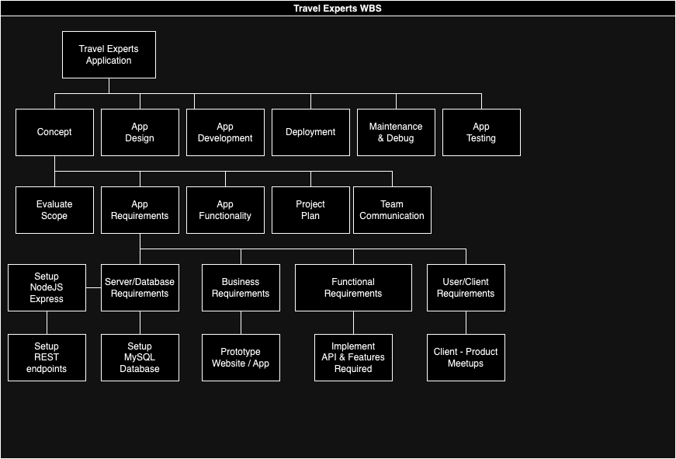
Travel Experts WBS

- 1.0 Concept
  - 1.1 Evaluate Scope
  - 1.2 App Requirements
    - 1.2.1 Server / Database Requirements
      - 1. Setup NodeJS / Express
        - A. Setup REST Endpoints
      - 2. Setup MySQL Database
    - 1.2.2 Business Requirements
      - 1. Prototype Website / Application
    - 1.2.3 Functional Requirements
      - 1. Implement API & Features Required
    - 1.2.4 User / Client Requirements
      - 1. Client - Product Meetups
  - 1.3 App Functionality
  - 1.4 Project Plan
  - 1.5 Team Communication

